MOBILE COMPUTING

MODULE -1

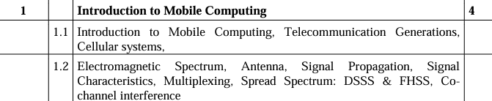

IMPORTANT QUESTIONS

Q1. Explain different types of Antenna used in mobile communication

Q2. What is Co-channel interference

Q3. What is spread spectrum

* Antenna and types
* Multiplexing
* DSSS and FHSS (Spread Spectrum)
* Frequency Reuse concept
* Cellular system

PYQ

Q1. What is spread spectrum?

Q2. Explain various types of antennas along with their radiation pattern

Q3. What are various mobile communication and application environments for the following: Business , Location Based Services , Banking Services , Vehicles

Q4. What is spread spectrum? What are the various advantages for the same?

Q5. What are various advantages and disadvantages of small cells in cellular system?

Q6. Explain DSSS and FHSS in detail

Q7. What are different types of antenna used in mobile communication

Q8. What is co-channel interference

Q9. Describe use of cellular IP X

Q10. Compare various Telecommunication Generations

Q11. Explain different application of mobile computing

Q12. Short note on : Co-Channel Interference

Q13. Discuss multiplexing in wireless communication

Q14. Short note on Antennae

Q1. Explain different types of Antenna used in mobile communication ||

Q2. Explain various types of antennas along with their radiation pattern ||

Q7. What are different types of antenna used in mobile communication ||

Q14. Short note on Antennae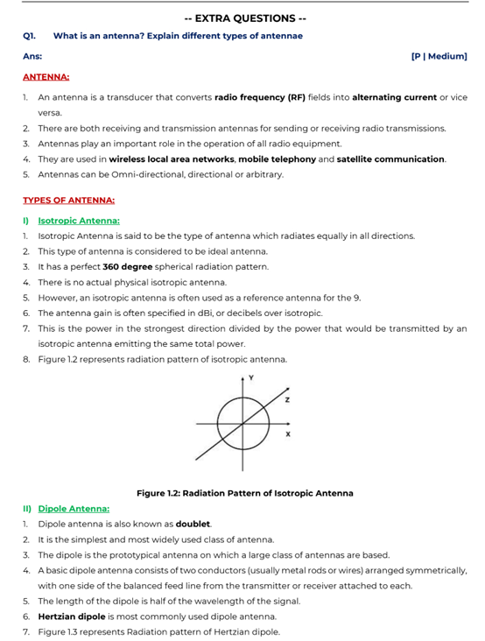

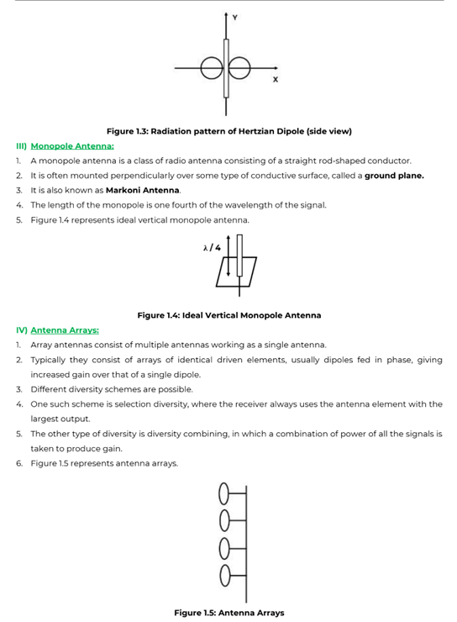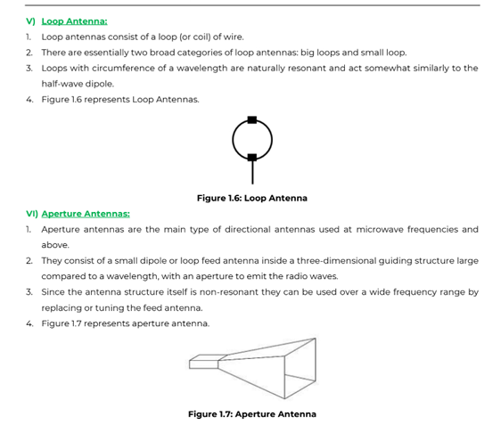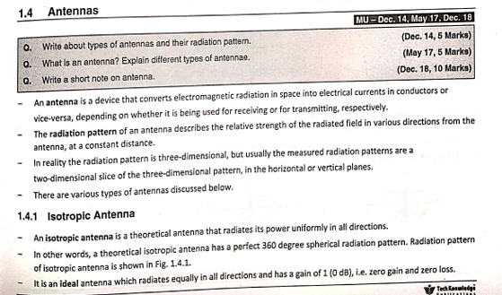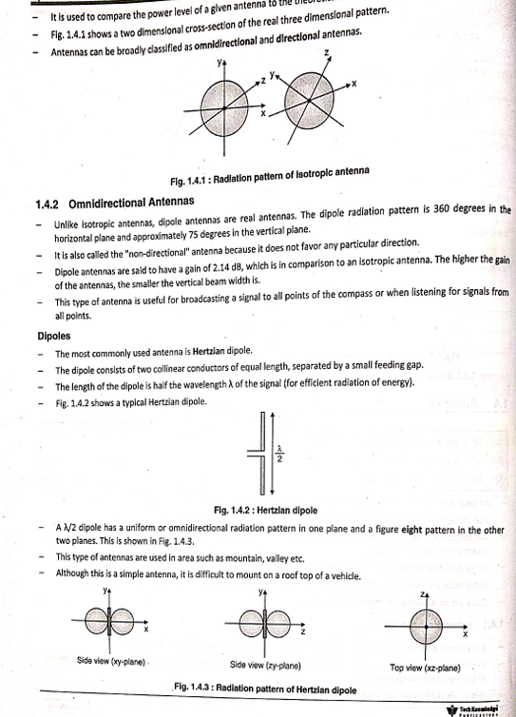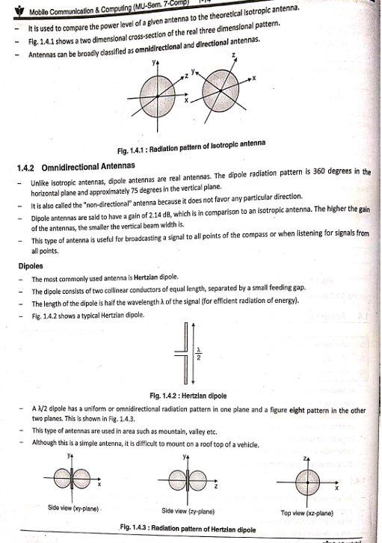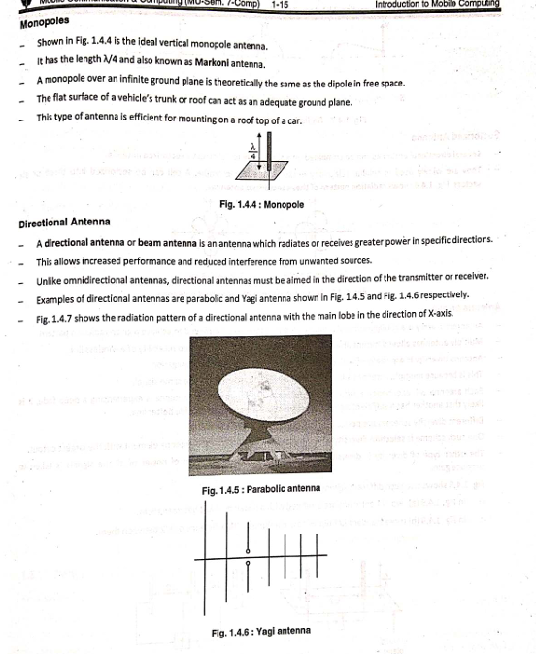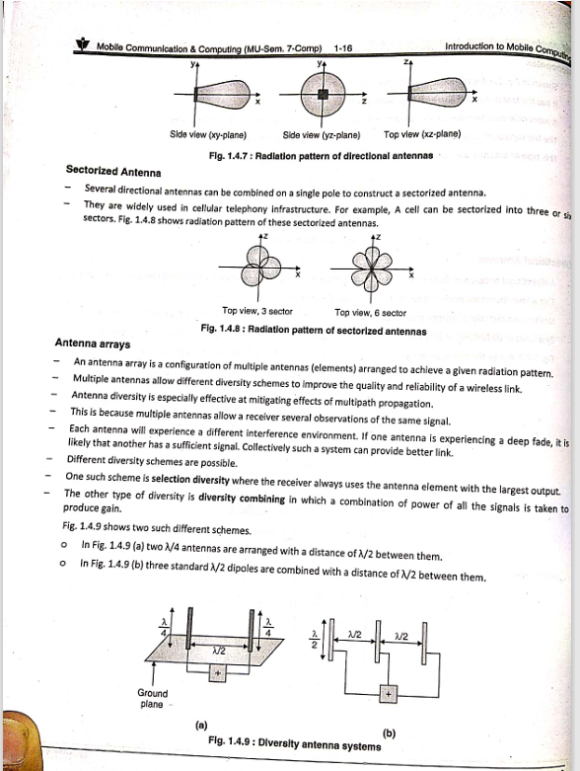

Q. What is Co-channel interference || Q8. What is co-channel interference ||

Q12. Short note on : Co-Channel Interference

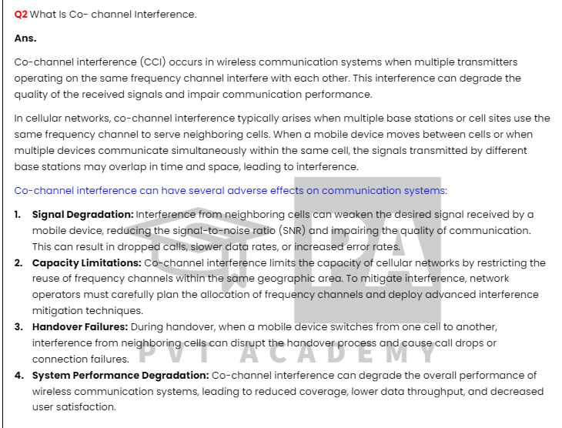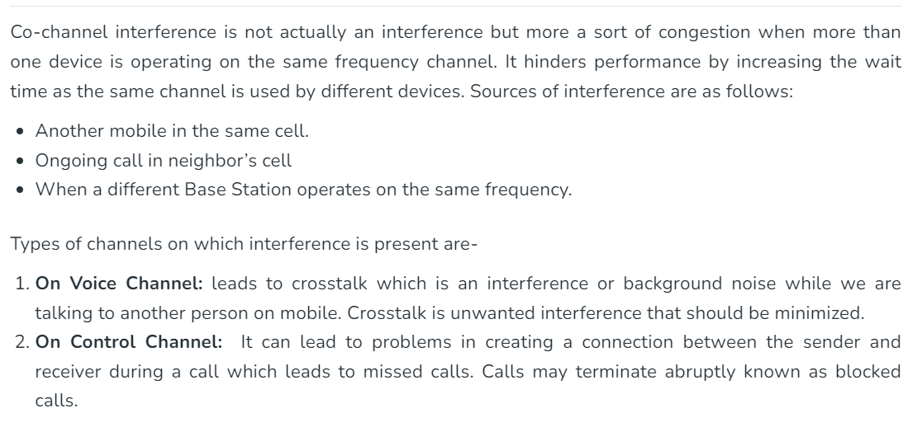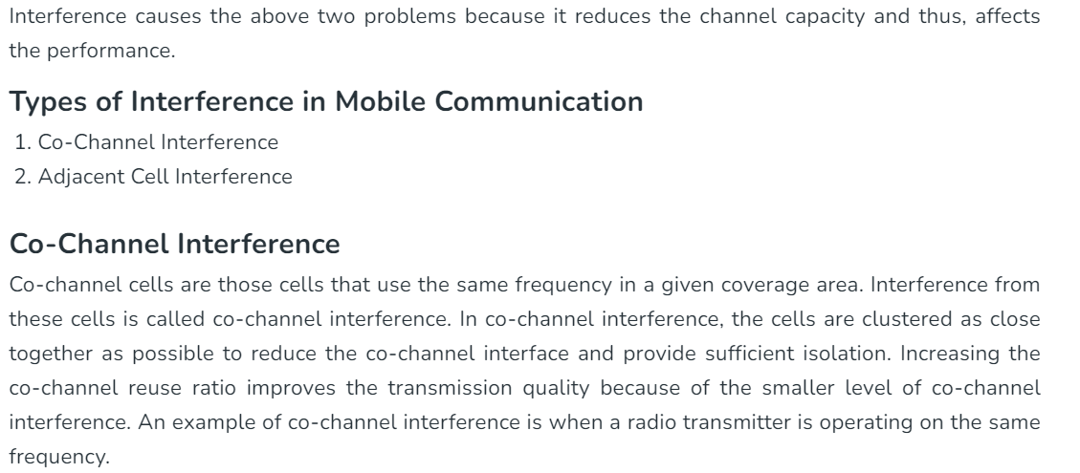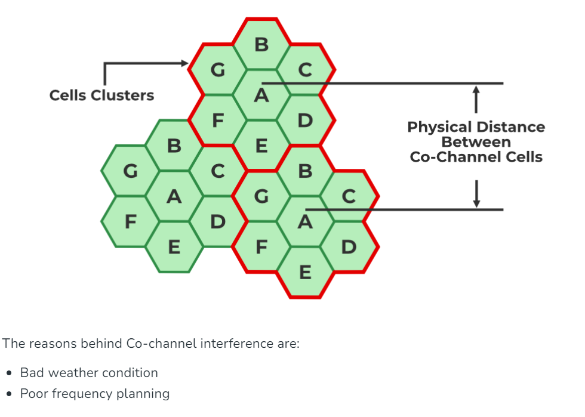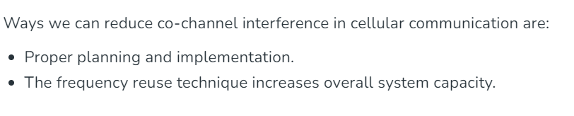

Q3. What is spread spectrum || Q1. What is spread spectrum? || Q4. What is spread spectrum? What are the various advantages for the same?

Spread spectrum is a communication technique used to enhance the reliability, security, and efficiency of wireless communication systems. It involves spreading the transmitted signal over a wide frequency band, much wider than the minimum bandwidth required to transmit the data. This method provides several benefits, such as resistance to interference, improved security, and efficient use of the available bandwidth.

### Key Concepts and Types of Spread Spectrum

1. **Frequency Hopping Spread Spectrum (FHSS)**:

- **Technique**: In FHSS, the carrier frequency of the transmitted signal rapidly changes (hops) among different frequencies within a specified band according to a pseudorandom sequence.

- **Benefits**:

- **Interference Resistance**: The rapid frequency changes make it difficult for narrowband interference to affect the signal consistently.

- **Security**: The pseudorandom hopping pattern provides a level of security since only the transmitter and receiver with the correct hopping sequence can synchronize and communicate.

2. **Direct Sequence Spread Spectrum (DSSS)**:

- **Technique**: In DSSS, the data signal is multiplied by a pseudorandom noise (PN) code, spreading the signal over a wider frequency band. The PN code has a higher rate than the original data signal, effectively spreading the signal.

- **Benefits**:

- **Interference Resistance**: The spreading process makes the signal appear as low-power noise to unintended receivers, making it more resistant to interference and jamming.

- **Multipath Resistance**: DSSS can mitigate the effects of multipath interference, where signals take multiple paths to reach the receiver, causing potential signal distortion.

- **Security**: The use of a pseudorandom code enhances the security, as only receivers with the correct code can despread the signal and recover the original data.

3. **Time-Hopping Spread Spectrum (THSS)**:

- **Technique**: In THSS, the signal is transmitted in short bursts at pseudorandom intervals, effectively spreading the signal in the time domain.

- **Benefits**:

- **Interference Resistance**: The use of random time slots helps avoid continuous interference and can make the signal less predictable.

### Applications of Spread Spectrum

- **Military and Defense**: Spread spectrum techniques were originally developed for military applications to provide secure and robust communication that is resistant to jamming and interception.

- **Cellular Networks**: Technologies such as CDMA (Code Division Multiple Access) use DSSS to allow multiple users to share the same frequency band simultaneously by assigning unique spreading codes.

- **Wi-Fi**: Many Wi-Fi standards (e.g., IEEE 802.11b) use DSSS to improve signal robustness and reduce interference in wireless local area networks.

- **GPS**: The Global Positioning System (GPS) employs DSSS to provide accurate positioning information, with resistance to interference and multipath effects.

- **Bluetooth**: Bluetooth uses FHSS to minimize interference from other wireless devices and improve communication reliability in short-range wireless networks.

### Advantages of Spread Spectrum

- **Interference Immunity**: Spread spectrum techniques distribute the signal across a wide frequency band, making it more resilient to narrowband interference and jamming.

- **Security**: The use of pseudorandom codes for spreading and hopping enhances the security of the communication, as unauthorized receivers without the correct code cannot easily intercept or decode the signal.

- **Multipath Mitigation**: Spread spectrum can reduce the impact of multipath propagation, where signals reflect off surfaces and cause interference.

- **Capacity**: Techniques like CDMA allow multiple users to share the same frequency band efficiently, increasing the capacity of communication systems.

### Conclusion

Spread spectrum is a powerful technique in wireless communication, providing robustness against interference, enhanced security, and efficient spectrum utilization. Its applications span across various domains, including military, cellular networks, Wi-Fi, GPS, and Bluetooth, making it a fundamental technology in modern wireless communication systems.

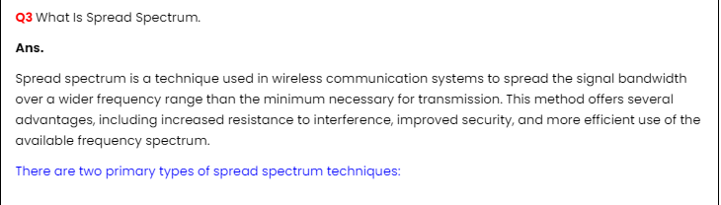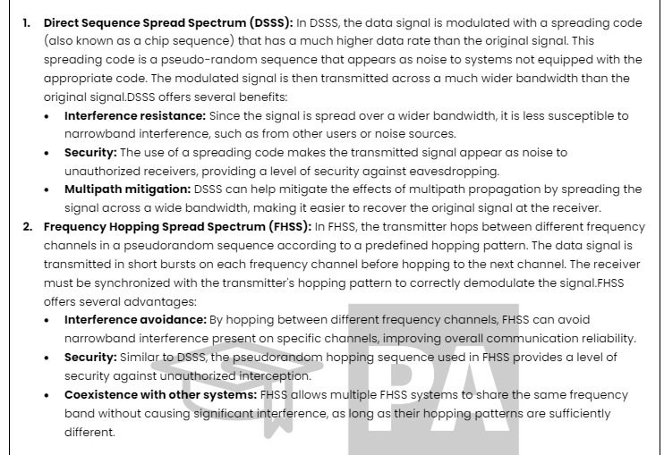

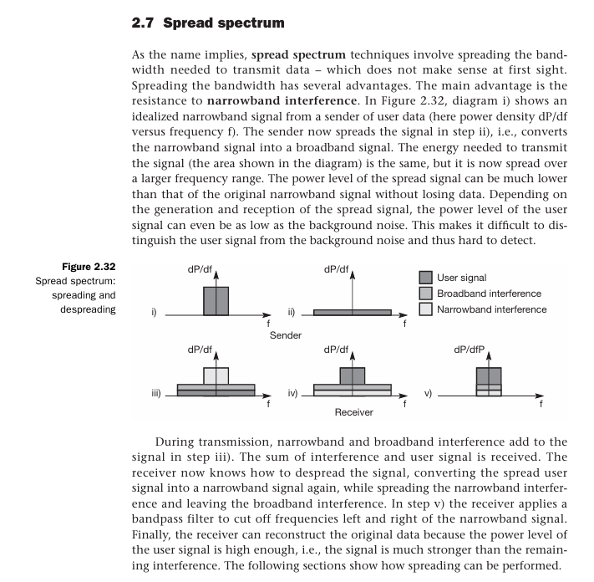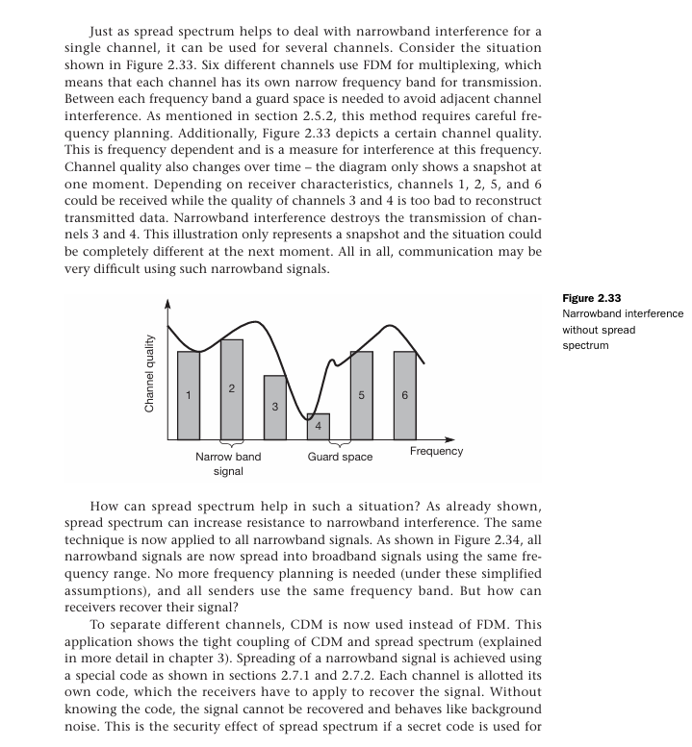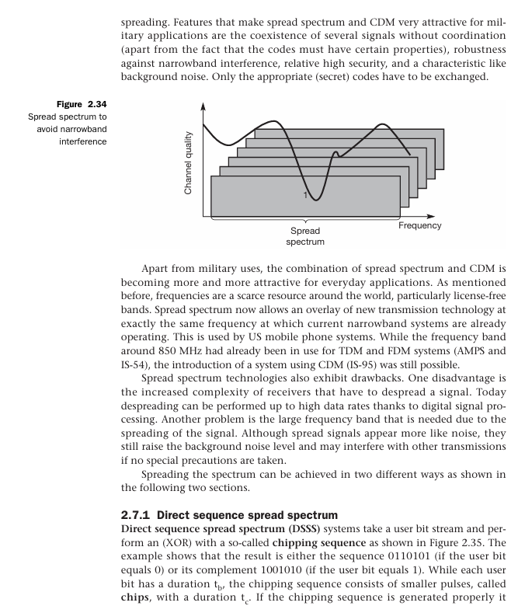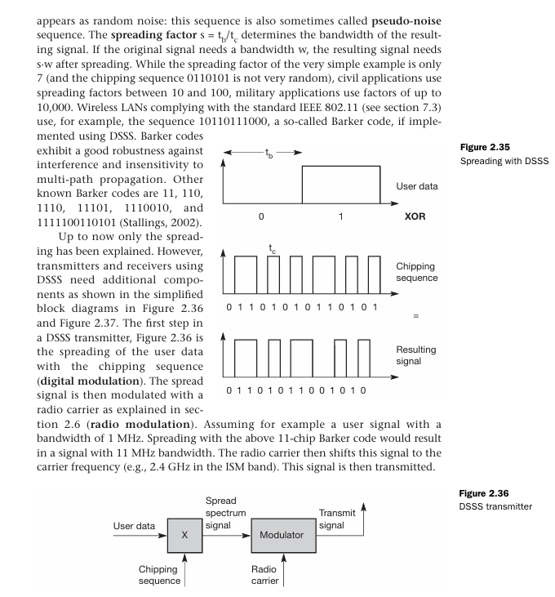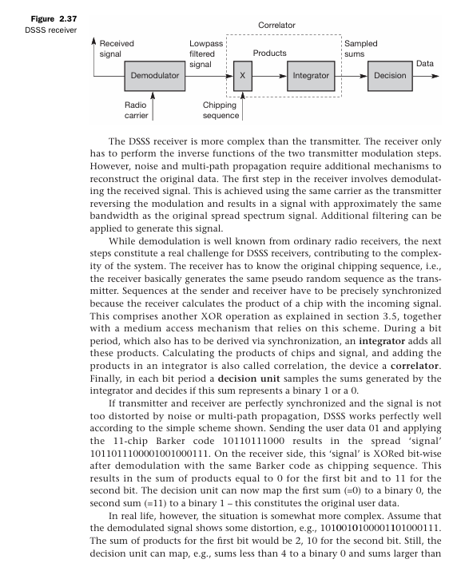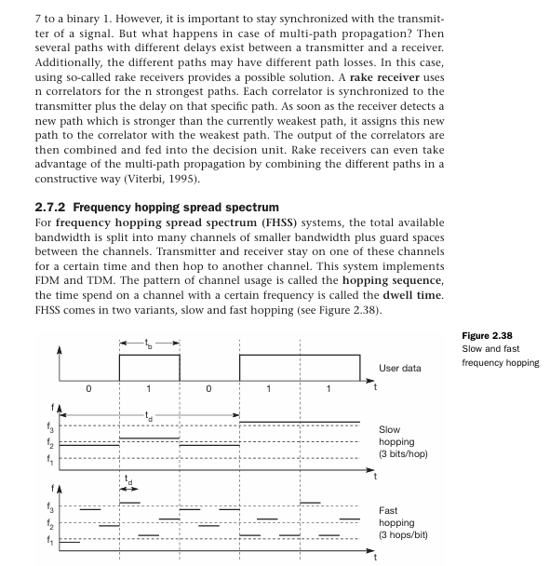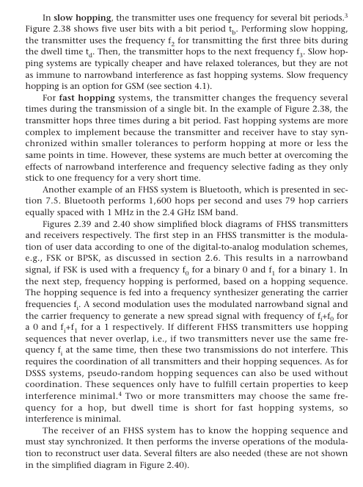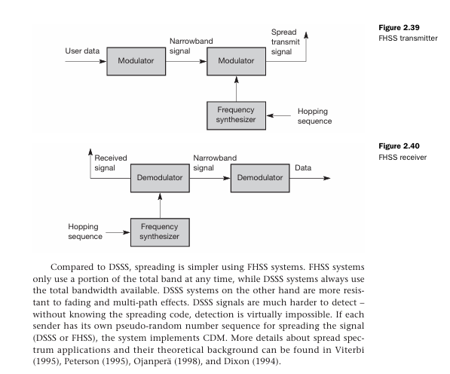

Q5. What are various advantages and disadvantages of small cells in cellular system?

Small cells are low-power, short-range cellular base stations designed to complement traditional macrocellular networks by providing enhanced coverage and capacity, particularly in densely populated urban areas and indoor environments. While small cells offer several advantages, they also come with certain disadvantages. Let's explore both aspects:

### Advantages of Small Cells:

1. **Improved Coverage and Capacity**:

- Small cells help fill coverage gaps and provide better signal strength in areas with poor macrocell coverage, such as indoor spaces, urban canyons, and rural areas.

2. **Enhanced Data Rates**:

- By reducing the distance between the user device and the base station, small cells can deliver higher data rates and improved quality of service (QoS) for users, especially in congested areas.

3. **Offloading Macrocell Traffic**:

- Deploying small cells offloads traffic from macrocellular networks, reducing congestion and improving overall network performance.

4. **Cost-Effective Deployment**:

- Small cells are typically less expensive to deploy compared to macrocells, making them a cost-effective solution for enhancing coverage and capacity in targeted areas.

5. **Flexibility and Scalability**:

- Small cells can be deployed incrementally to address specific coverage and capacity needs, allowing operators to scale their network infrastructure based on demand.

6. **Low Power Consumption**:

- Due to their small size and lower transmit power, small cells consume less power compared to macrocells, contributing to energy efficiency and reduced operational costs.

### Disadvantages of Small Cells:

1. **Limited Coverage Area**:

- Small cells have a limited coverage range, typically ranging from tens to a few hundred meters, which may require a higher density of deployments to achieve comprehensive coverage in large areas.

2. **Interference and Handover Challenges**:

- In areas with overlapping coverage from multiple small cells or macrocells, interference and handover issues may arise, affecting network performance and seamless connectivity for users.

3. **Backhaul Requirements**:

- Small cells require reliable backhaul connectivity to connect to the core network, which may pose challenges in terms of availability, capacity, and cost, especially in urban environments.

4. **Site Acquisition and Zoning Issues**:

- Acquiring suitable sites for small cell deployment, obtaining regulatory approvals, and addressing zoning regulations can be time-consuming and complex, delaying network rollout and increasing deployment costs.

5. **Management and Maintenance**:

- Managing a large number of distributed small cell sites can be more complex and resource-intensive compared to managing macrocell sites, requiring effective monitoring, maintenance, and optimization to ensure optimal network performance.

6. **Limited Spectrum Resources**:

- Small cells rely on available spectrum resources, which may become congested in densely populated areas or urban environments, limiting the capacity and performance benefits they can deliver.

### Conclusion:

While small cells offer significant advantages in terms of coverage enhancement, capacity augmentation, and cost-effectiveness, they also present challenges related to coverage limitations, interference management, backhaul requirements, and regulatory considerations. Deploying small cells effectively requires careful planning, coordination, and optimization to maximize their benefits and mitigate potential drawbacks in cellular systems.

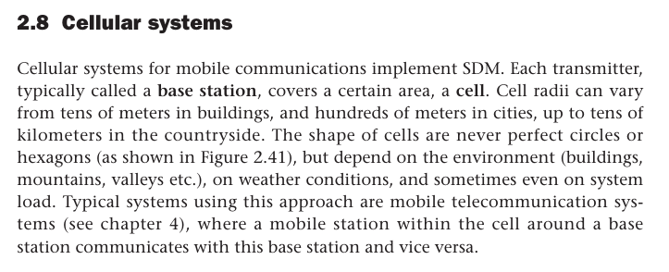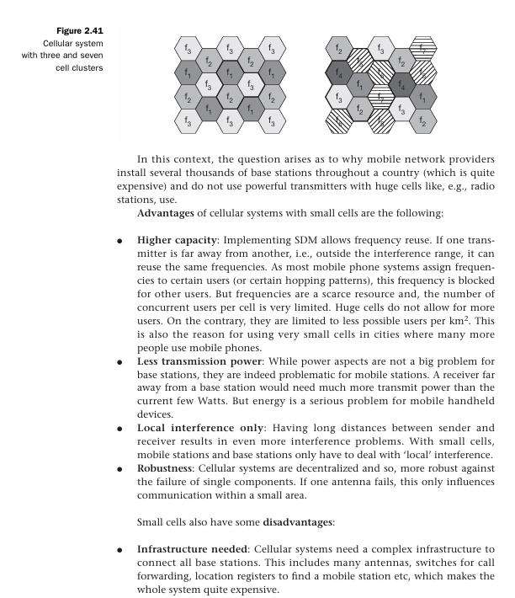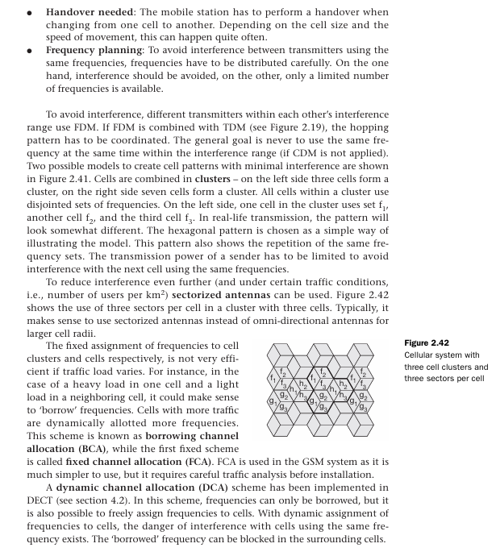

Q10. Compare various Telecommunication Generations

| **Aspect** | **1G** | **2G** | **3G** | **4G** | **5G** |
| --- | --- | --- | --- | --- | --- |
| **Introduction Year** | 1980s | Early 1990s | Late 1990s | Early 2010s | Late 2010s |
| **Main Technology** | Analog | Digital (CDMA, GSM) | Digital (WCDMA, CDMA2000) | LTE (Long-Term Evolution) | NR (New Radio) |
| **Data Transfer Speed** | Up to 2.4 kbps | Up to 384 kbps | Up to 2 Mbps | Up to 100 Mbps (mobile) | Up to several Gbps (mobile) |
| **Key Features** | Voice Calls | Digital Voice Calls | Voice Calls, Limited Data | High-Speed Data, Mobile Internet | Enhanced Mobile Broadband (eMBB), Ultra-Reliable Low Latency Communication (URLLC), Massive Machine Type Communication (mMTC) |
| **Network Architecture** | Analog | Circuit-Switched | Circuit-Switched, Packet-Switched | Packet-Switched | Packet-Switched |
| **Frequency Bands** | N/A | GSM: 900 MHz, 1800 MHz | UMTS: 2100 MHz | LTE: 700 MHz, 2.6 GHz | mmWave, Sub-6 GHz |
| **Interoperability** | N/A | Roaming between Operators | Global Roaming | Global Roaming | Global Roaming |
| **Security** | Low | Improved | Enhanced Security Features | Enhanced Security Features | Enhanced Security Features |
| **Usage** | Basic Voice Communication | Voice Calls, SMS | Voice Calls, SMS, Basic Data | High-Speed Data, Mobile Internet | Various IoT Applications, Enhanced Mobile Broadband (eMBB) |

Q. Explain different application of mobile computing

Mobile computing refers to the use of portable computing devices, such as smartphones, tablets, and laptops, to access and process information while on the move. These devices are equipped with wireless communication capabilities, enabling users to connect to the internet and interact with various applications and services from virtually anywhere. Here are different applications of mobile computing:

### 1. **Communication:**

- **Voice Calls and Messaging**: Making phone calls and sending text messages are basic communication functions of mobile devices.

- **Video Calls**: Apps like Skype, FaceTime, and Zoom allow users to make video calls, enabling face-to-face communication over long distances.

- **Email**: Accessing and managing email accounts on mobile devices for communication and collaboration.

### 2. **Information Access:**

- **Web Browsing**: Mobile browsers like Chrome, Safari, and Firefox enable users to access websites, search for information, and consume online content.

- **Search Engines**: Mobile search engines like Google Search provide instant access to a vast array of information, services, and resources.

- **Social Media**: Apps like Facebook, Twitter, Instagram, and LinkedIn facilitate social networking, content sharing, and communication with friends and colleagues.

### 3. **Entertainment:**

- **Streaming Media**: Apps like Netflix, YouTube, Spotify, and Apple Music enable users to stream movies, TV shows, music, and podcasts on their mobile devices.

- **Gaming**: Mobile gaming has become increasingly popular, with a wide range of games available for download from app stores, catering to casual and hardcore gamers alike.

- **E-books and Digital Magazines**: Reading e-books and digital magazines on mobile devices using apps like Kindle, iBooks, and Flipboard.

### 4. **Navigation and Location-Based Services:**

- **Maps and Navigation**: GPS-enabled mobile devices provide real-time navigation, driving directions, and location-based services through apps like Google Maps, Apple Maps, and Waze.

- **Location-Based Recommendations**: Apps like Yelp, TripAdvisor, and Foursquare provide location-based recommendations for restaurants, hotels, attractions, and services.

### 5. **Productivity and Business Applications:**

- **Email and Calendar**: Mobile email clients and calendar apps help users manage their schedules, appointments, and tasks on the go.

- **Document Editing and Collaboration**: Apps like Microsoft Office, Google Docs, and Dropbox enable users to create, edit, and collaborate on documents, spreadsheets, and presentations.

- **Project Management**: Mobile project management apps like Trello, Asana, and Basecamp help teams organize tasks, track progress, and collaborate on projects remotely.

### 6. **Financial Services:**

- **Mobile Banking**: Banking apps allow users to check account balances, transfer funds, pay bills, and manage finances securely from their mobile devices.

- **Mobile Payments**: Apps like Apple Pay, Google Pay, and PayPal enable users to make secure payments in stores, online, and peer-to-peer using their mobile devices.

### 7. **Health and Fitness:**

- **Activity Tracking**: Fitness apps and wearable devices track physical activity, exercise, sleep patterns, and health metrics like heart rate and calorie expenditure.

- **Diet and Nutrition**: Apps like MyFitnessPal, Lose It!, and Fitbit help users monitor their diet, track calorie intake, and achieve fitness goals.

### 8. **Home Automation and IoT (Internet of Things):**

- **Smart Home Control**: Mobile apps allow users to control smart home devices such as thermostats, lights, security cameras, and appliances remotely.

- **IoT Integration**: Mobile devices can interact with a variety of IoT devices and sensors to monitor and control connected systems, such as smart home, healthcare, and industrial applications.

### 9. **Education and Learning:**

- **E-learning Platforms**: Mobile learning apps and platforms provide access to educational resources, courses, tutorials, and interactive content for self-paced learning.

- **Language Learning**: Apps like Duolingo, Rosetta Stone, and Babbel help users learn new languages through interactive lessons and exercises.

### 10. **Emergency Services and Disaster Management:**

- **Emergency Alerts**: Mobile devices receive emergency alerts and notifications for natural disasters, severe weather, and other critical events, providing timely information and instructions to users. - **Emergency Response Apps**: Apps like FEMA, Red Cross, and Citizen enable users to report emergencies, receive assistance, and access resources during emergencies and disasters.

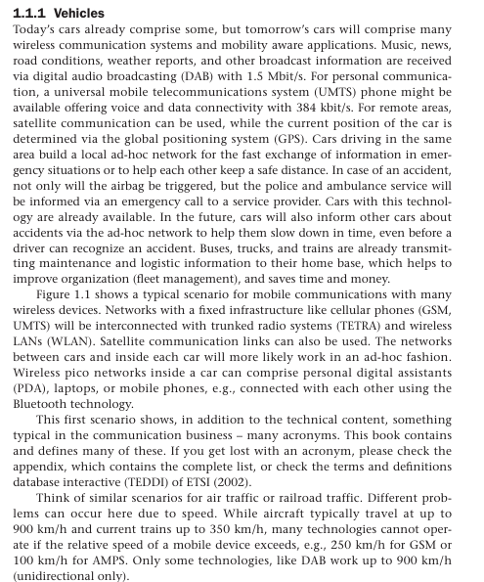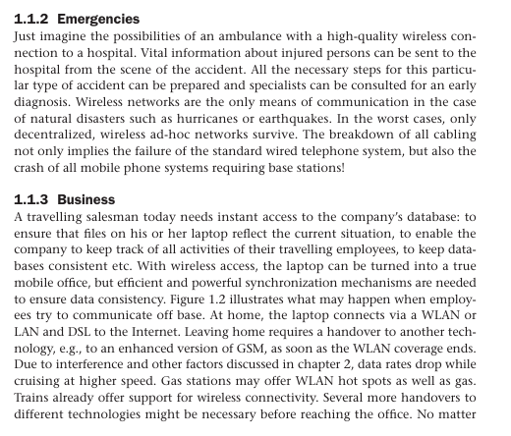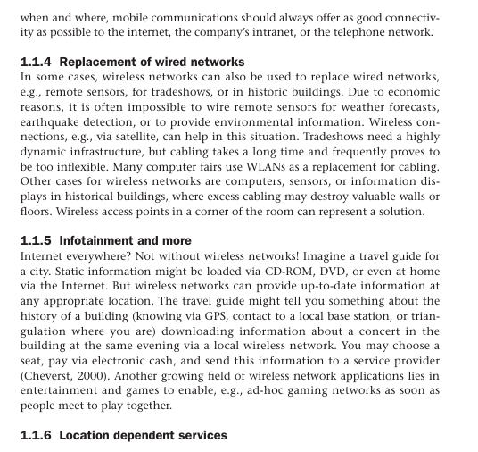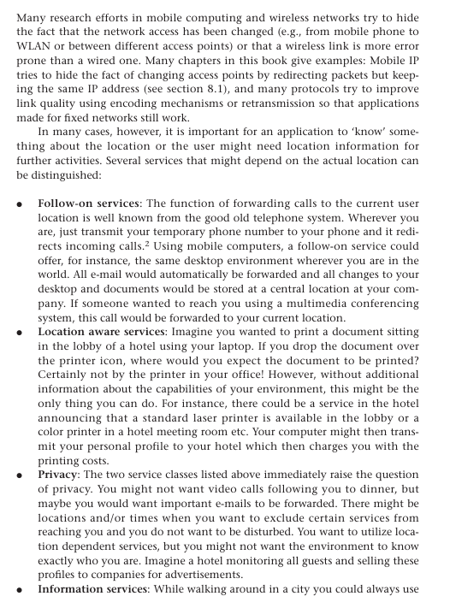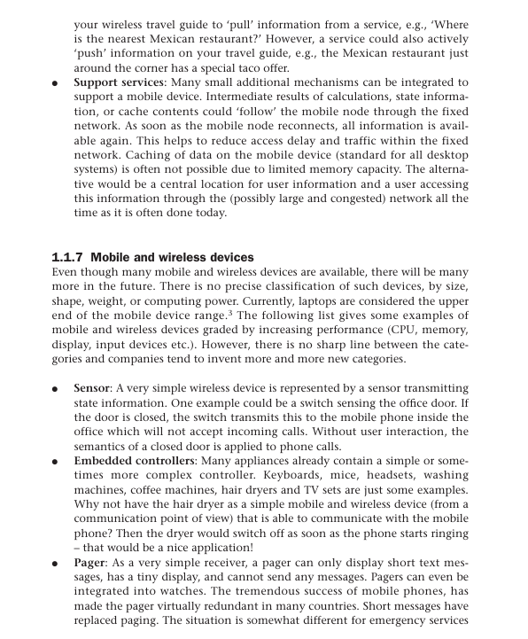

Q. Discuss multiplexing in wireless communication

Multiplexing in wireless communication refers to the technique of transmitting multiple signals or data streams over a shared communication channel simultaneously. This allows multiple users or devices to share the available bandwidth efficiently, thereby maximizing the utilization of the communication channel. Multiplexing is essential for accommodating the growing demand for wireless communication services and supporting various applications with diverse bandwidth requirements. Here are some common multiplexing techniques used in wireless communication:

### 1. Frequency Division Multiplexing (FDM):

- **Principle**: FDM divides the available frequency spectrum into multiple non-overlapping frequency bands or channels. Each channel is allocated to a different user or communication stream.

- **Implementation**: Each user or communication stream is assigned a unique frequency band within the allocated spectrum.

- **Advantages**:

- Simple implementation.

- Supports simultaneous transmission of multiple signals.

- Suitable for analog and digital transmission.

- **Disadvantages**:

- Fixed allocation of frequency bands may lead to inefficient use of spectrum.

- Susceptible to interference and crosstalk between adjacent frequency bands.

### 2. Time Division Multiplexing (TDM):

- **Principle**: TDM divides the available time slots in a communication channel into discrete time intervals. Each time interval is assigned to a different user or communication stream.

- **Implementation**: Users take turns transmitting their data during their allocated time slots.

- **Advantages**:

- Efficient utilization of the communication channel.

- Guarantees equal access to the channel for all users.

- Suitable for both digital and analog transmission.

- **Disadvantages**:

- Synchronization issues may arise between transmitter and receiver.

- Inefficient for bursty traffic patterns.

### 3. Code Division Multiplexing (CDM) / Code Division Multiple Access (CDMA):

- **Principle**: CDMA assigns a unique spreading code to each user or communication stream. All users transmit simultaneously over the same frequency band, but their signals are distinguished by their unique spreading codes.

- **Implementation**: Spread spectrum techniques are used to spread the signals over a wider bandwidth, allowing multiple signals to coexist without interference.

- **Advantages**:

- Robust against interference and jamming.

- Supports asynchronous transmission and variable data rates.

- Enables efficient use of spectrum resources.

- **Disadvantages**:

- Requires careful design to minimize cross-correlation between spreading codes.

- Complexity increases with the number of users.

### 4. Orthogonal Frequency Division Multiplexing (OFDM):

- **Principle**: OFDM divides the available frequency spectrum into multiple narrow subcarriers that are orthogonal to each other. Data is transmitted simultaneously over multiple subcarriers.

- **Implementation**: Each subcarrier carries a portion of the data stream, and the signals are combined at the receiver.

- **Advantages**:

- High spectral efficiency and resistance to frequency-selective fading.

- Supports high data rates and robust performance in multipath environments.

- Suitable for broadband communication systems.

- **Disadvantages**:

- Susceptible to synchronization errors and inter-symbol interference.

- Complexity increases with the number of subcarriers.

### Applications of Multiplexing in Wireless Communication:

- Cellular networks (e.g., 4G LTE, 5G NR) use multiplexing techniques to support multiple users and services simultaneously.

- Wi-Fi networks employ OFDM to maximize data rates and coverage in wireless LANs.

- Satellite communication systems utilize CDMA and frequency division multiple access (FDMA) for efficient use of satellite bandwidth.

- Broadband wireless systems (e.g., WiMAX) use OFDM to deliver high-speed internet access to users.

In summary, multiplexing plays a crucial role in wireless communication by enabling efficient sharing of the available bandwidth among multiple users and services. Each multiplexing technique has its advantages and disadvantages, and the choice of technique depends on factors such as system requirements, channel conditions, and compatibility with existing infrastructure.

